DHA-Website Layout

(revised)

**Index**

Structure / Linking

Start page

Navigation block

Section View

List View - rows

List View - grid

List Item - Event

List Item - Project

List Item - Biblio

List Item - Institution

Detail node view (#6198)

Detail - Event

Detail - Biblio

Detail - Project

Detail - Institution

Tags (#5170)

Tags as filter

Tags as Glossary

The [digital-humanities.at](http://digital-humanities.at/) website serves as a platform for information dissemination and exchange for the Austrian digital humanities community.

It is maintained and developed primarily by the [Austrian Centre for Digital Humanities](http://acdh.oeaw.ac.at/).

For more details about the overall application and development see [redmine-Wiki](https://redmine.acdh.oeaw.ac.at/projects/dha-website/wiki/Wiki)

# Structure / Linking

Page wise content loading

Paging should happen client-side, i.e. for given list all items are returned at once (no paging-parameters) (also because the API does not support explicit sorting.



# Start page

logo + the four main tiles, pointing to the corresponding list-views

Content from: [https://dhdev.eos.arz.oeaw.ac.at/en/api_0_1/nodes?parameters[field_tags]=209](https://dhdev.eos.arz.oeaw.ac.at/en/api_0_1/nodes?parameters%5Bfield_tags%5D=209)



# Navigation block

Content from: [https://dhdev.eos.arz.oeaw.ac.at/en/api_0_1/nodes?parameters[field_tags]=214](https://dhdev.eos.arz.oeaw.ac.at/en/api_0_1/nodes?parameters%5Bfield_tags%5D=214)

Contains:

* Menu
* Language switch
* Search
* Tags

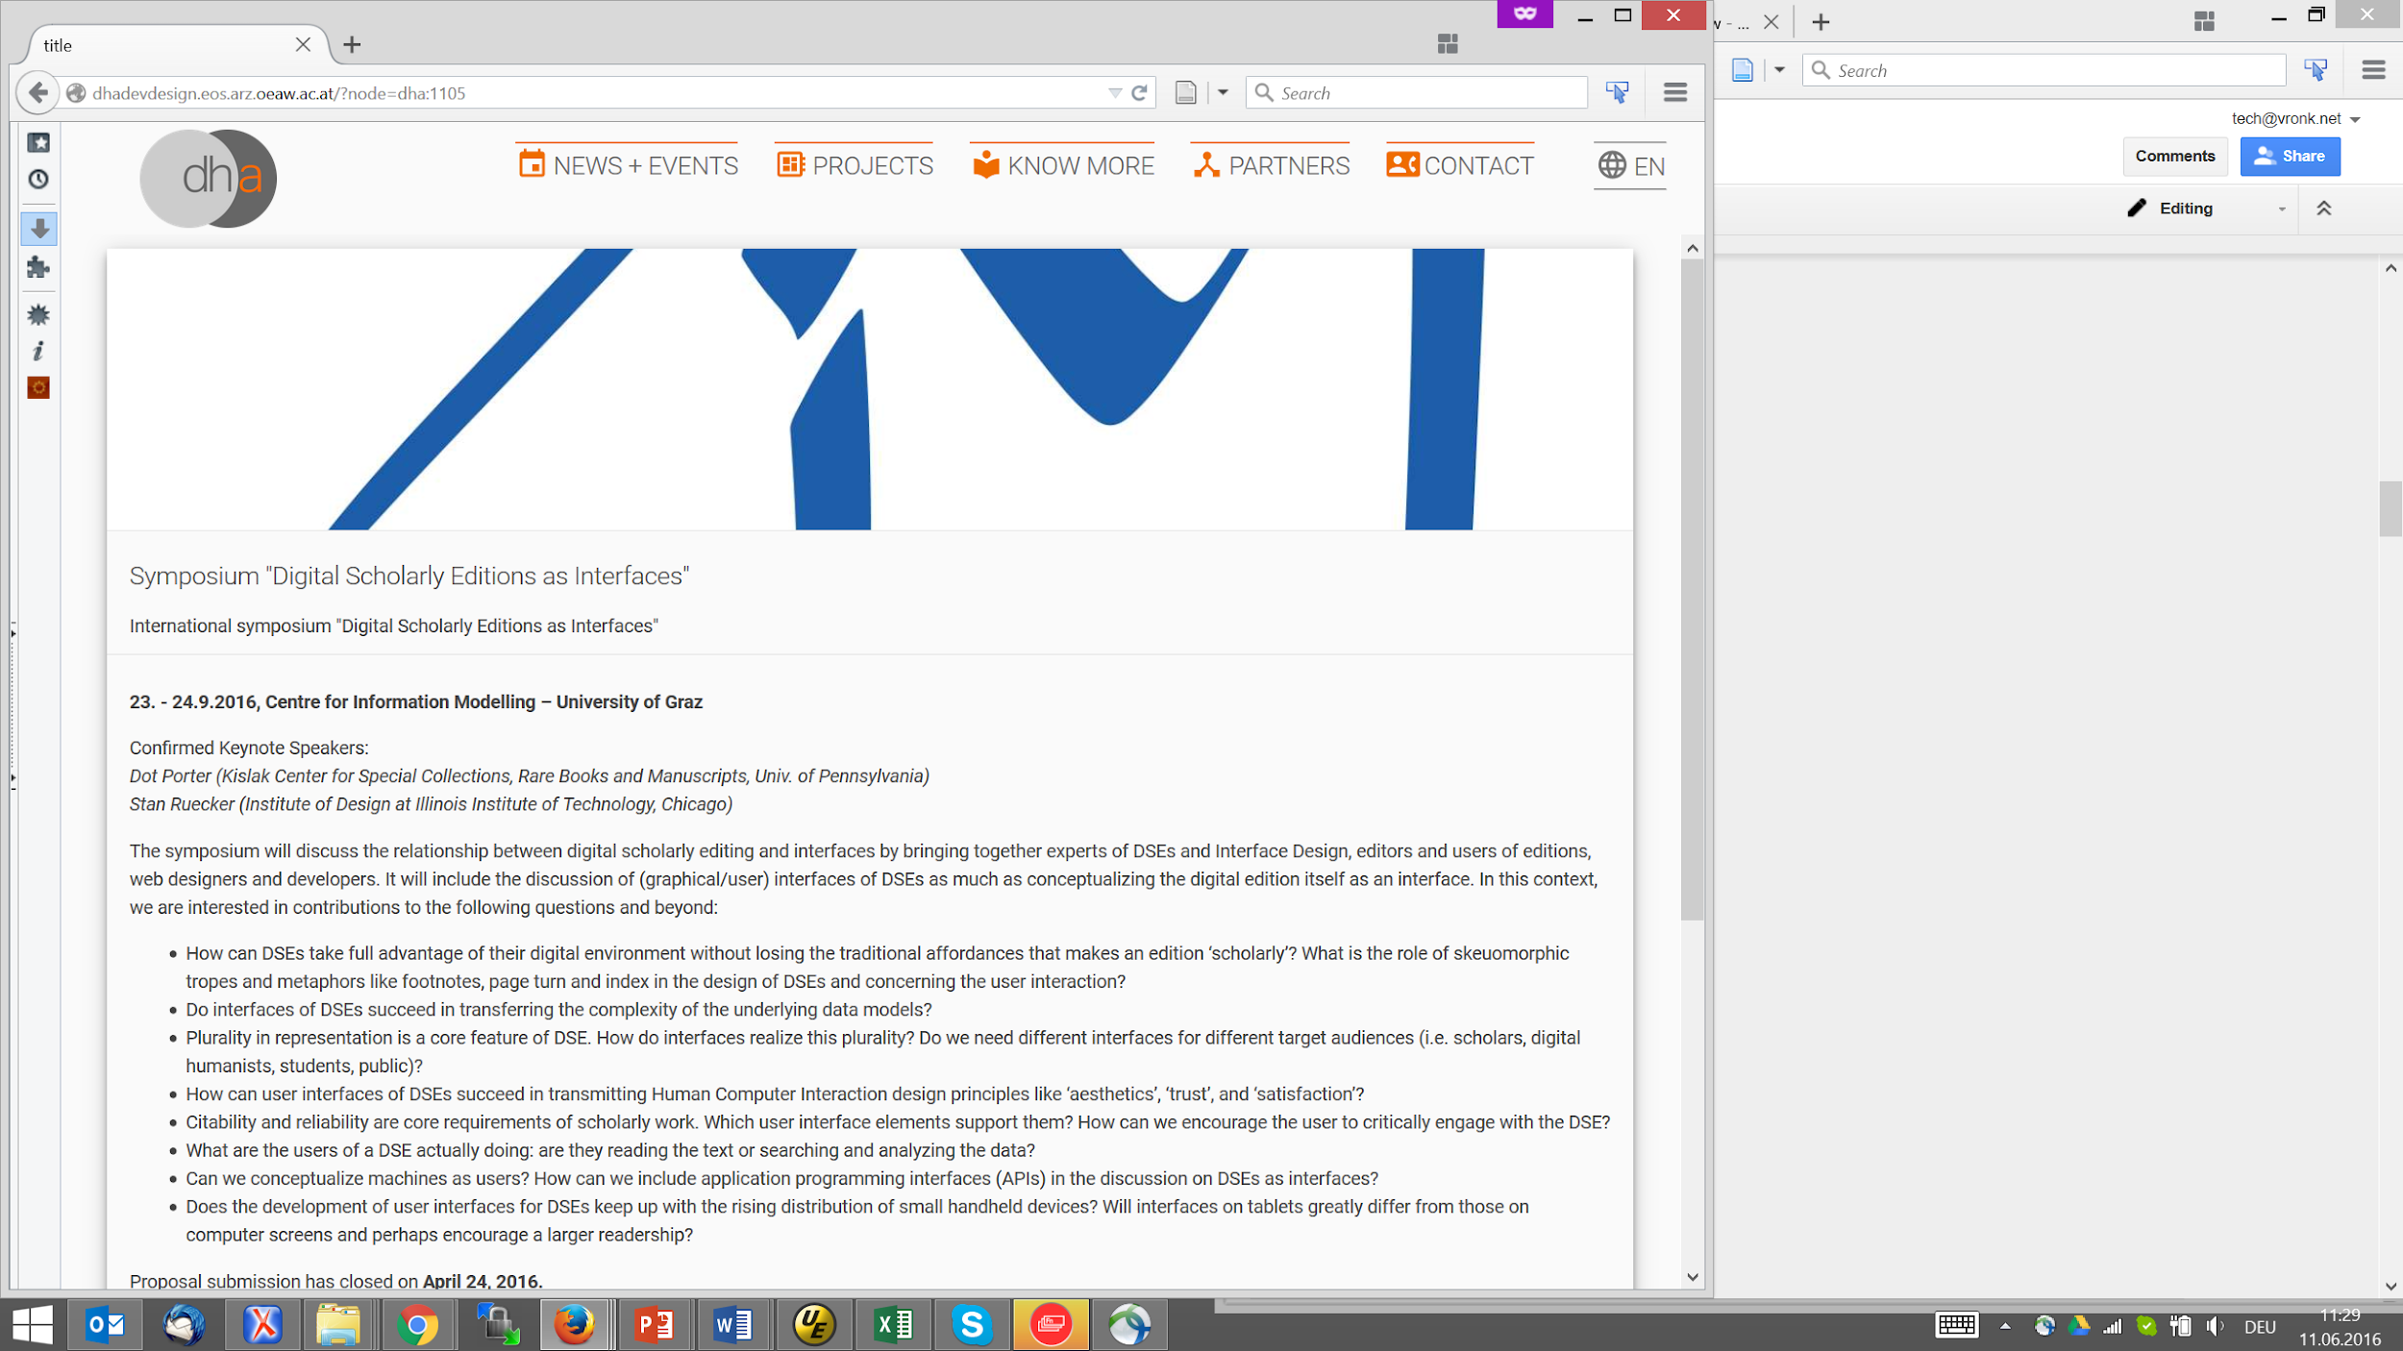

# Section View

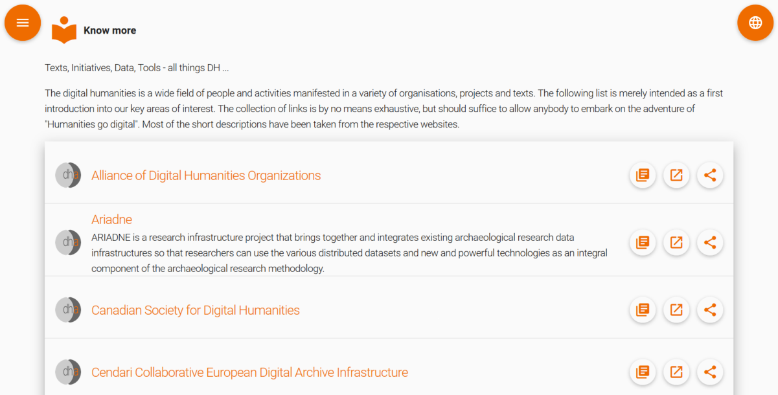

### List View - rows

<http://dhadevdesign.eos.arz.oeaw.ac.at/?page=Projects>

Content for the list view is restricted by type, tags, or other query

Each item in the list has: Thumbnail, Title, Tags, Link, Teaser-text - This may need to be customized per type (see below)

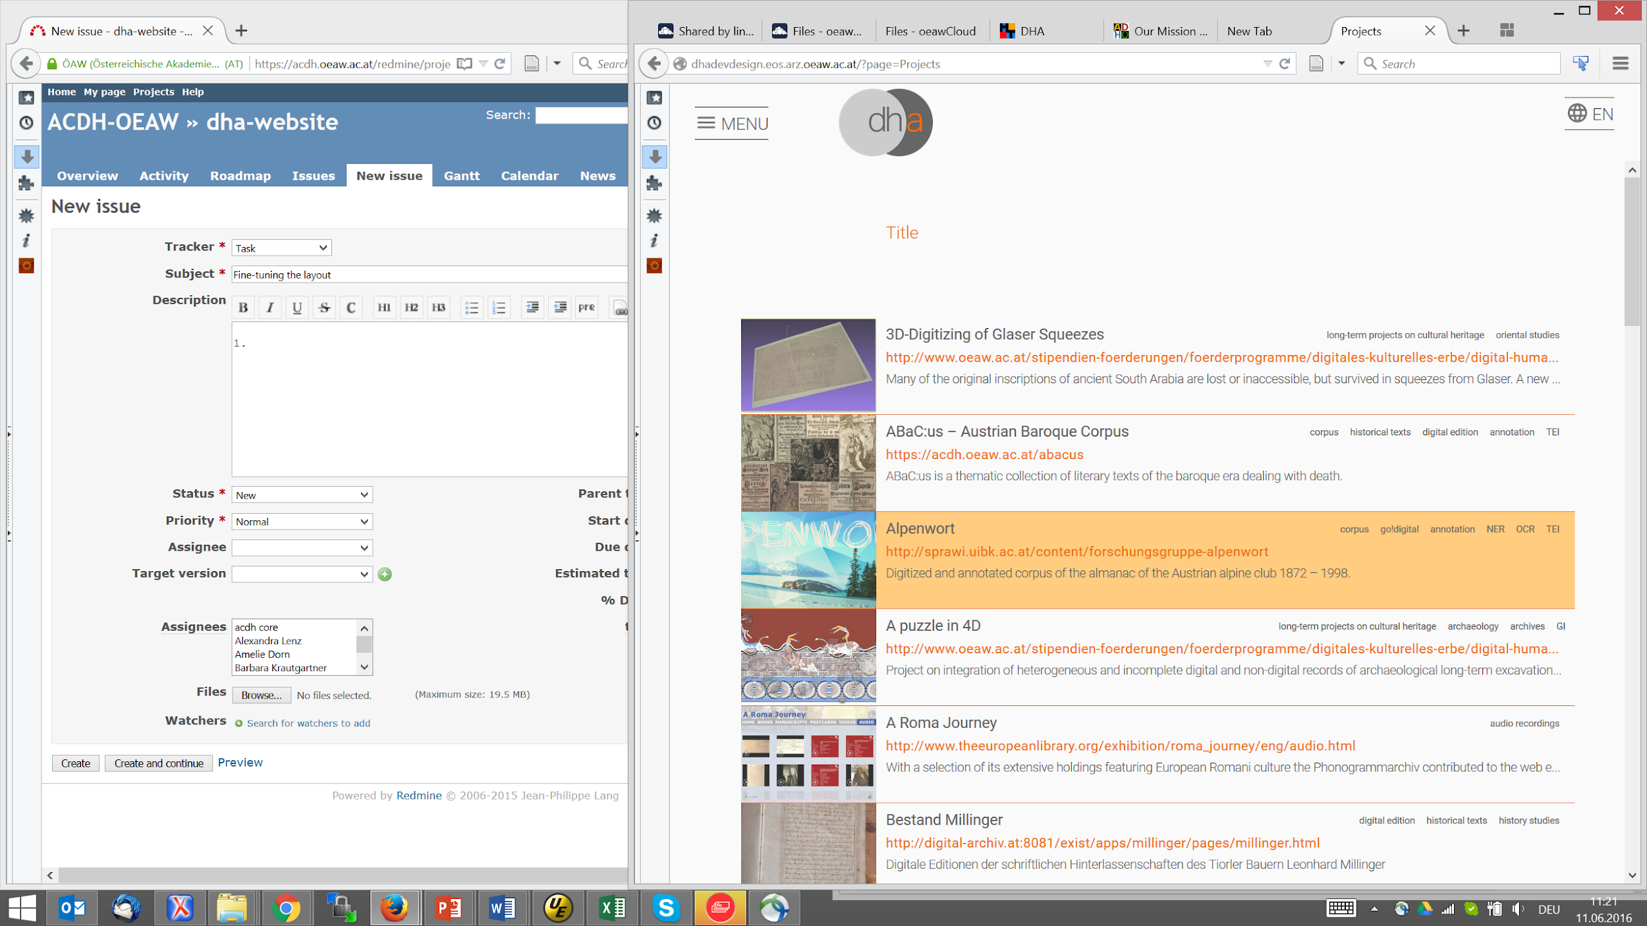

### List View - grid

Each item should feature title, thumbnail, teaser

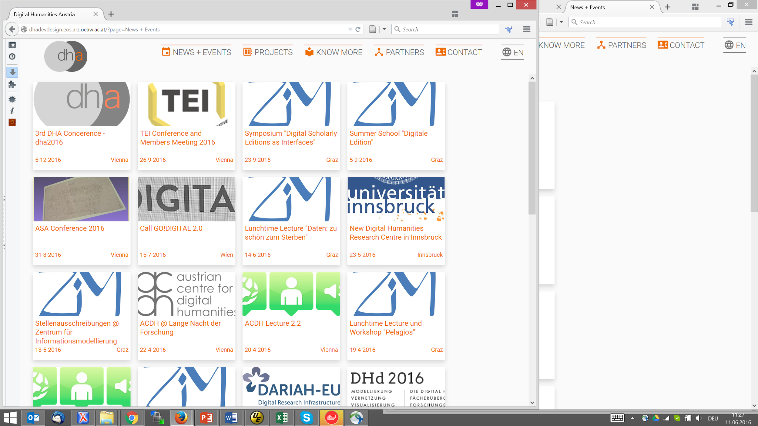

### List Item - Event

List and grid

### List Item - Project

### List Item - Biblio

### List Item - Institution

# Detail node view ([#6198](https://redmine.acdh.oeaw.ac.at/issues/6198))

(e.g.:<http://dhadevdesign.eos.arz.oeaw.ac.at/?node=dha:993>)

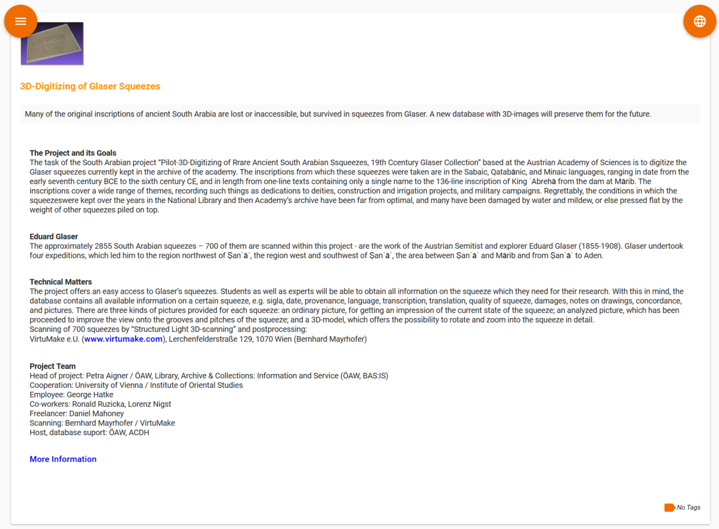

### Detail - Event

### Detail - Biblio

### Detail - Project

### Detail - Institution

# Tags ([#5170](https://redmine.acdh.oeaw.ac.at/issues/5170))

Tags serve mainly for filtering the content on the website,

But also as a glossary with definitions for the terms

### Tags as filter

a complete (hierarchical) list of the tags as a separate block that pops-up as part of the navigation

Different views should be possible: html-tree, tag-cloud, graph

### Tags as Glossary

Similar with tags in the navigation block, but not as filter, but full-page content (including explanations